Chapter 6: Systems of Inequalities

6.4 – Systems of Inequalities (More practice)

Sketch the graph of the solution of the system of inequalities and state one point in the solution set.

1. $2x^{2}+y≥2$ 2. $x-y^{2}>0$
$x≤2$ $x-y<2$
$y≤1$
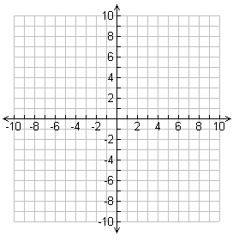

3. $x^{2}+y^{2}≤25$ 4. $y<-x^{2}+2x+3$
$4x-3y≤0$ $y> x^{2}-4x+3$

